Version Control:
No adjustments may be made to this document without completing the tracking table below and adjusting the date and version number above accordingly.
 | Version | Name | Title | Date | Comments
The relationship between students and their supervisors, as well as the role of the Research Office and the Higher Degrees and Research Committee, are key components affecting the success of thesis.
Since conflict and tension can arise in situations where expectations, roles, and responsibilities are unclear or mismatched, it is helpful to have a clear agreement on such issues.
Regenesys  Awakening Potential | Memorandum of Understanding Thesis Students & Supervisors
Regenesys  Awakening Potential | Date Issued: January 2021 Version # 3
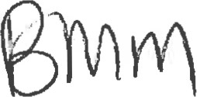
This Memorandum of Understanding offers a shared understanding of the responsibilities of students, supervisors, and Regenesys administrators. The agreement creates an opportunity to clarify individual expectations and inform one another of challenges that may arise during the course of researching and writing a dissertation.
The student is primarily responsible for the completion and submission of their own thesis/dissertation and should therefore demonstrate ongoing motivation and deep commitment throughout the course of the research process.
This document is based on the following Regenesys policy and guideline documents:
i. Academic Regulations Handbook ii. Administration and Supervision of Research Thesis Policy and Procedures iii. Research and Publications Policy iv. Guidelines for Compiling a Mini-Dissertation
v. Supervision Guidelines vi. Referencing Guidelines vii. Student Declaration of Responsibility: Research for the Purpose of a Doctor's Degree

THE STUDENT
l, HAPPINESSS THULUBHEKE ZWANE understand, and agree to perform, the following roles and take the following responsibilities:-
- I will adhere to the relevant rules and regulations of Regenesys Business School;
- I will work independently under the guidance of my supervisor, and ensure that she or he stays abreast of the latest developments in the programme;
- I will agree with my supervisor on, and abide by, a research schedule that outlines the expected completion dates of various stages of my research work;
- I will attend scheduled meetings (in person or via skype) with my supervisor, and be adequately prepared. I will duly inform my supervisor, should I need to cancel our appointment due to circumstances beyond my control;
- I will submit written work at times agreed upon with my supervisor;
- I will take account of the feedback provided by my supervisor before submitting further work;
Regenesys  Awakening Potential | Memorandum of Understanding Thesis Students & Supervisors
Regenesys  Awakening Potential | Date Issued: January 2021 Version # 3
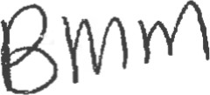
- I will plan to, and submit, my thesis/dissertation within the prescribed time for the completion of the degree, unless exceptional circumstances arise;
- I will accept responsibility for the overall clarity and coherence of my final thesis/dissertation and will, as far as possible, submit work that is correctly formatted, and free of spelling mistakes, grammatical errors, and inconsistent referencing;
- I will inform my supervisor of any personal circumstances that may affect my research process and our agreed research schedule; and,
- If any disagreement/conflict should arise, I will inform the relevant research administrators and provide substantive proof, in order to request supervisor reallocation, understanding fully, that the matter will be considered by the research committee and a final decision will subsequently be made based on information gathered from both parties.
- I will accept feedback from the external examiner as constructive feedback; therefore, should I be required to make amendments suggested by him/her, I will do so with the understanding that the external examiner will review my thesis/dissertation objectively, and their feedback may require minor changes if I receive a conditional pass, OR major changes if I obtain a fail. I will consult with my supervisor where applicable, and implement those changes for the benefit of improving my final dissertation mark.

Signature Date 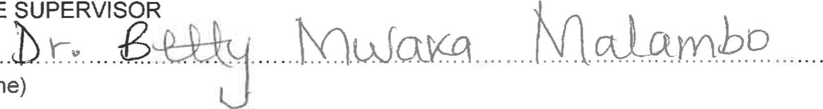name) understand, and agree to perform, the following roles and take the following responsibilities:1 . I will adhere to the relevant rules and regulations of Regenesys Business School;
THE
- I will assist my student(s) in building research skills and subject matter knowledge in the specific areas of Business Management or Public Management appropriate to the level of the degree;
- I will ensure that my student(s) proposed research project is feasible; is relevant to business/ public management/development/leadership, and of an appropriate level for the degree under consideration;
- I will assist my student(s) to develop a realistic research schedule that outlines the expected completion dates of various stages of the research work, and to make satisfactory progress against the schedule's milestones;
Regenesys  Awakening Potenti91 | Memorandum of Understanding Thesis Students & Supervisors
Regenesys  Awakening Potenti91 | Date Issued: January 2021 Version # 3
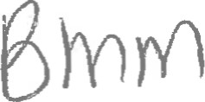
- I will be accessible to my student(s) by scheduling and attending meetings (in person or via skype) agreed upon in advance, and being prepared for the meetings. I will duly inform my student, should J need to cancel our appointment due to circumstances beyond my control.
- I will implement an arrangement for my student(s)' co-supervision in cases where t am, for whatever reasons, temporarily or permanently unable to meet my own commitments in terms of the agreed research schedule, and will communicate these arrangements to my student(s) and Research Department timeously;
- I will accept the submission of my student(s)' work at agreed intervals, provide constructive comment and criticism within an agreed time-frame, and clearly inform the student of any inadequacy in their work in particular or progress in general;
- I will assist the student with the production of the dissertation, by providing guidance on the technical aspects of research, writing, referencing, and formatting in line with Regenesys' requirements as well as any relevant subject matter-specific requirements; and
- I will assist with the co-publication of research articles based on my student(s)' dissertation in accordance with Regenesys' policies;
- If any disagreement/conflict should arise, I will inform the relevant research administrators and provide substantive proof, in order to request the department's intervention, understanding fully, that the matter will be considered by the research committee and a final decision will subsequently, be made based on information gathered from both parties; and
Regenesys  Awakening Potential | Memorandum of Understanding Thesis Students & Supervisors
Regenesys  Awakening Potential | Date Issued: January 2021 Version # 3
- I will accept feedback from my student's external examiner as constructive feedback; therefore, should implementation of their feedback indeed strengthen the validity and reliability of the student's dissertation, I understand that I will guide the student accordingly, and provide clarity where the external examiner may have misunderstood/misinterpreted what the student intended to convey. I understand that the purpose of an external examiner is to review my student's dissertation objectively, and their feedback to my student may require minor changes if they receive a conditional pass, OR major changes if they obtain a fail. I will consult with the relevant Regenesys administrator(s) should I need clarity of the external examiner's rationale of their decision in order to improve the quality of my supervision, as well as for the improvement of my student's final mark.
Signature Date

